INSTALLING ANALYTIC BUSINESS EXPLORER

INITIAL PREREQUISITES
The installation of the Analytic Business Explorer software requires the following hardware and software prerequisites:
Hardware*:
- RAM: min 2 GB, 4 GB recommended;
- Processor: multicore.
Operating system:
- Windows 10/Windows Server 2012 R2 or later.
Software:
- Internet Information Services with .NET Framework v2.0;
- Microsoft SQL Server 2008 or later;
- Clients require a PC / Tablet with an updated browser.
* The hardware specifications depend directly on the amount of data that will be processed.
Once the hardware and software requirements have been checked, it is necessary to proceed by accessing your reserved area on the site https://clienti.analytic.it/ with the download of the desired files from the following:
- be_srv_setup_xxx.exe*;
- be_scheduler_setup_xxx.exe*;
- be_manager_setup_xxx.exe*;
- be_updater_xxx.exe*;
- benetweb_xxx-full.zip* or benetweb_xxx-nomaps.zip* depending on the desired site version.
* With xxx we mean the desired software version.
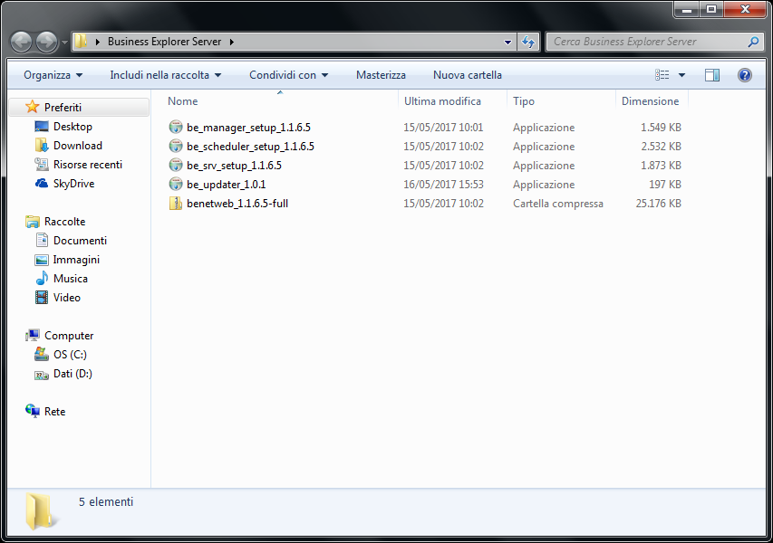
After downloading, right-click on each file, select “Properties”, “Cancel block” and finally “Apply”.

TIP
Before proceeding with the installation it is advisable to create (for example on disk D:\) A “Business Explorer” folder and the following sub-folders:
- “Release”;
- “Models”;
- “Prefetch”;
- “Log”;
- “Web”.
Then copy the previously downloaded files to the “Release” folder you just created.

INSTALLING ANALYTIC BUSINESS EXPLORER SERVER
Run as administrator be_srv_setup_xxx.exe by right-clicking on the file and selecting “Run as administrator”.
Follow the installation wizard by selecting “Next”.
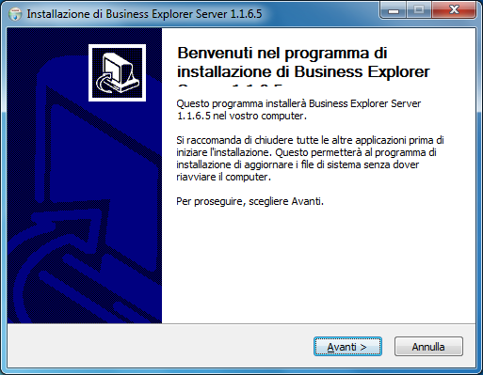
Specify the destination folder and select “Next”.
If you do not want to install the Analytic Business Explorer Manager on the same user, remove the “Manager” flag automatically checked.
Finally select “Install”.
In the “Database Access” tab, fill in the “Server Name” field with the name of the server in question (“localhost” if there is only one instance), the “Authentication Type” field by selecting “Windows Authentication” from the menu drop-down and the “Application Database” field with the name of a database created by the user (if this was not done previously, use the “Create” button to do so now). Finally click on the “Test” button.
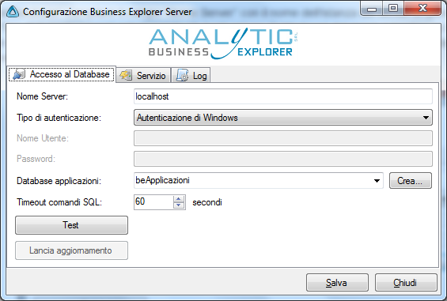
If the procedure has been followed correctly you can now read the message “Connection successful”.
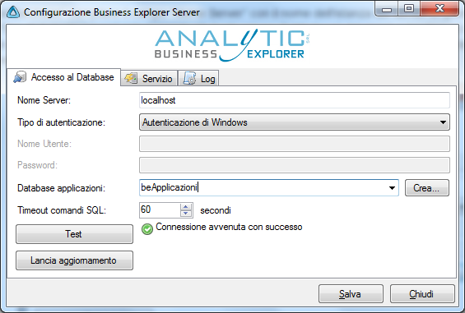
In the “Service” tab the first three fields will be completed; fill in the “Prefetch Directory” field by selecting the destination path (D:\BusinessExplorer\Prefetch if you followed the initial suggestion).
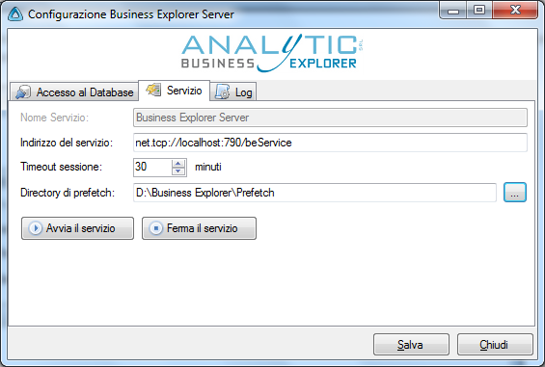
In the “Log” tab, fill in the “Log Level” field under the “Log on text file” field by selecting “Disabled” or “Error” and the “Log file path” field from the drop-down menu by selecting the destination path (D:\BusinessExplorer\Log if you have followed the initial suggestion) and naming the file as “beNet.log”, under the “Log SQL” entry the “Log level” field by selecting “Warning” from the drop-down menu, under “Log on Application Log” the “Log level” field by selecting “Error” from the drop-down menu and the “Application name” field with “Business Explorer Server”.
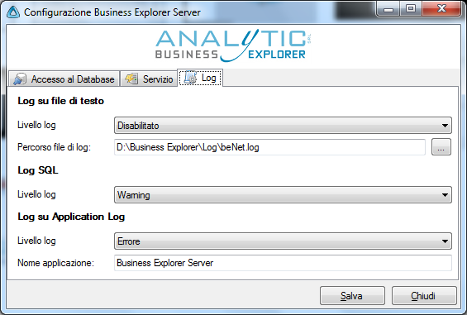
Go back to the “Service” tab and click the “Start service” button. If the service has been started correctly, you will see the relevant message box.
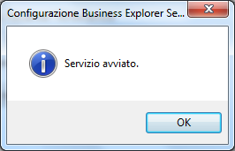
Finally click on the “Save” button.
After the procedure select “Finish”.
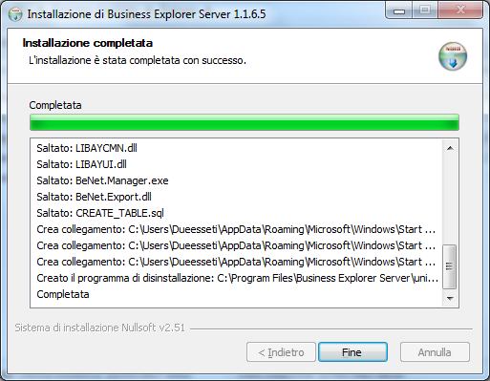
Now the “Business Explorer Manager” icon will be available in the Windows toolbar, execute it; if the installation was successful, the following screen will appear.
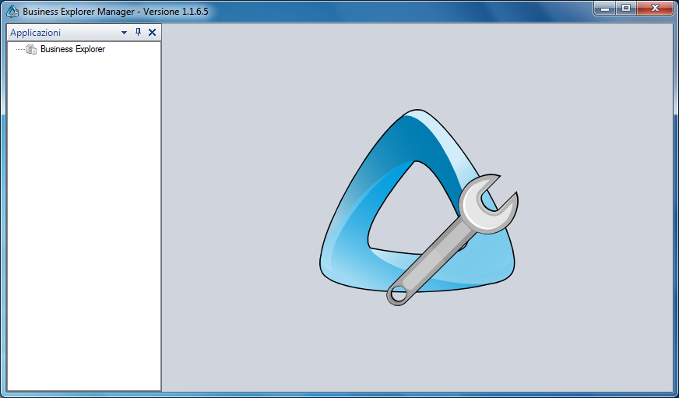

WEB CONFIGURATION
Unzip the benetweb_xxx-full.zip or benetweb_xxx-nomaps.zip file into the Analytic Business Explorer software path (D:\BusinessExplorer\Web if you followed the initial suggestion).
Rename the default_web file on the web to the newly unpacked folder (D:\BusinessExplorer\Web if you followed the initial suggestion).
If the web server is different from the Analytic Business Explorer Server installation server or if the service parameters have been changed, replace the service address with the server installation parameters. To do this, refer to the following section within the web file:
<endpoint address="net.tcp://localhost:790/beService/service.svc" binding="netTcpBinding" bindingConfiguration="netTCP" contract="BeNet.Interfaces.IBeService" name="endpoint"/>
<endpoint address="net.tcp://localhost:791/beSchedulerService/service.svc" binding="netTcpBinding" bindingConfiguration="netTCP" contract="BeNet.Scheduler.Interfaces.ISchedService" name="epscheduler"/>
<endpoint address="net.tcp://localhost:7790/beUpdate/service.svc" binding="netTcpBinding" bindingConfiguration="netTCP" contract="BeNet.Updater.Interfaces.IUpdaterService" name="epupdate"/>
And modify the string
net.tcp://localhost: 790/
with the server installation parameters.
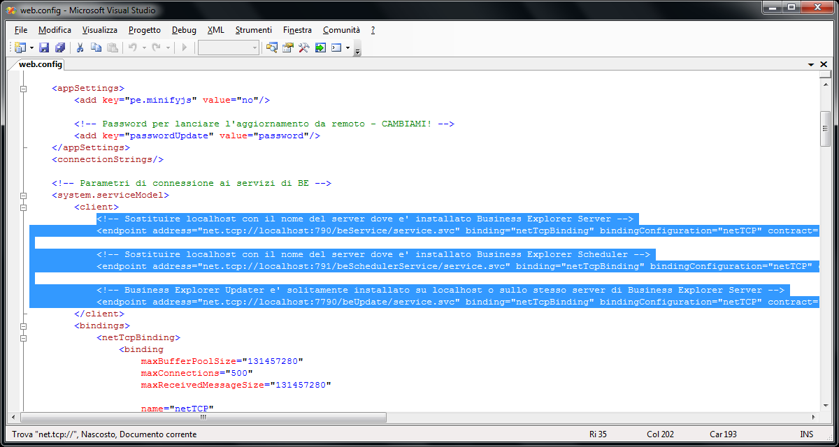
Also change the “false” parameter to “true” within the following section of the web file:
<system.web>
<compilation debug="false">
<assemblies>
To have a specific localization, add a globalization parameter to System.Web section :
<system.web>
<globalization uiCulture="IT" culture="IT-it" />
From the Windows toolbar select Start, search for Internet Information Services (IIS) Manager and run it.
Once executed, from the menu on the left of the IIS screen open the dropdown of the server instance and finally select the “Application pool” item.
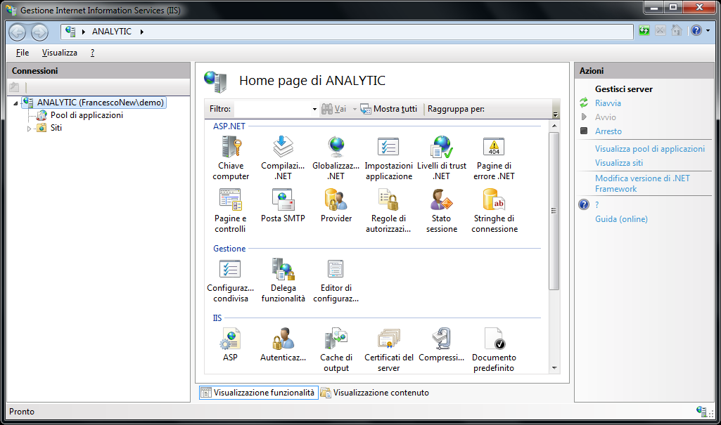
Add the “BE” application pool in the “Application pool” and start it.
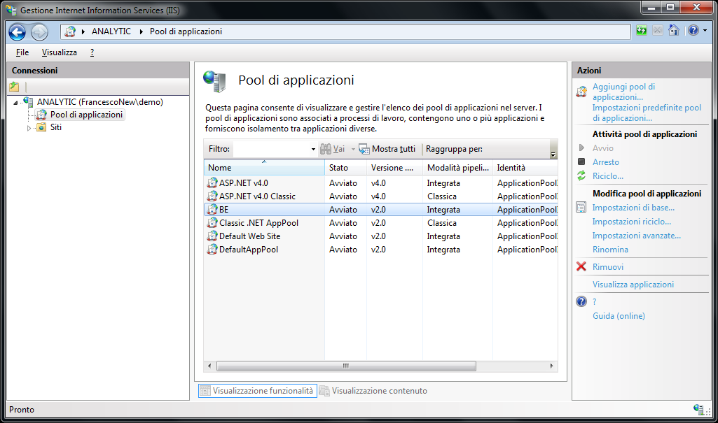
If IIS has not already been configured to run sites based on .NET framework, run the following shell command:
C:\Windows\Microsoft.NET\Framework64\v2.0.50727>aspnet_regiis -i
Select the “Sites” item and right-click to add a new website.
Complete the “Site Name” field with BE and select the BE application pool; indicate the path D:\Business Explorer\Web“and if necessary specify different Binding options from the preset ones, then click “Ok”.
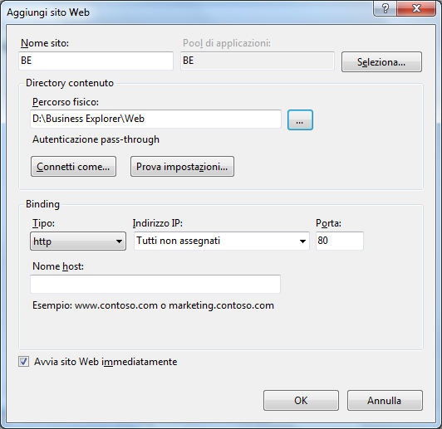
From the menu on the right select the item Explore Binding* in the “Manage website” drop-down menu. If the web configuration was successful, the following screen will be displayed.
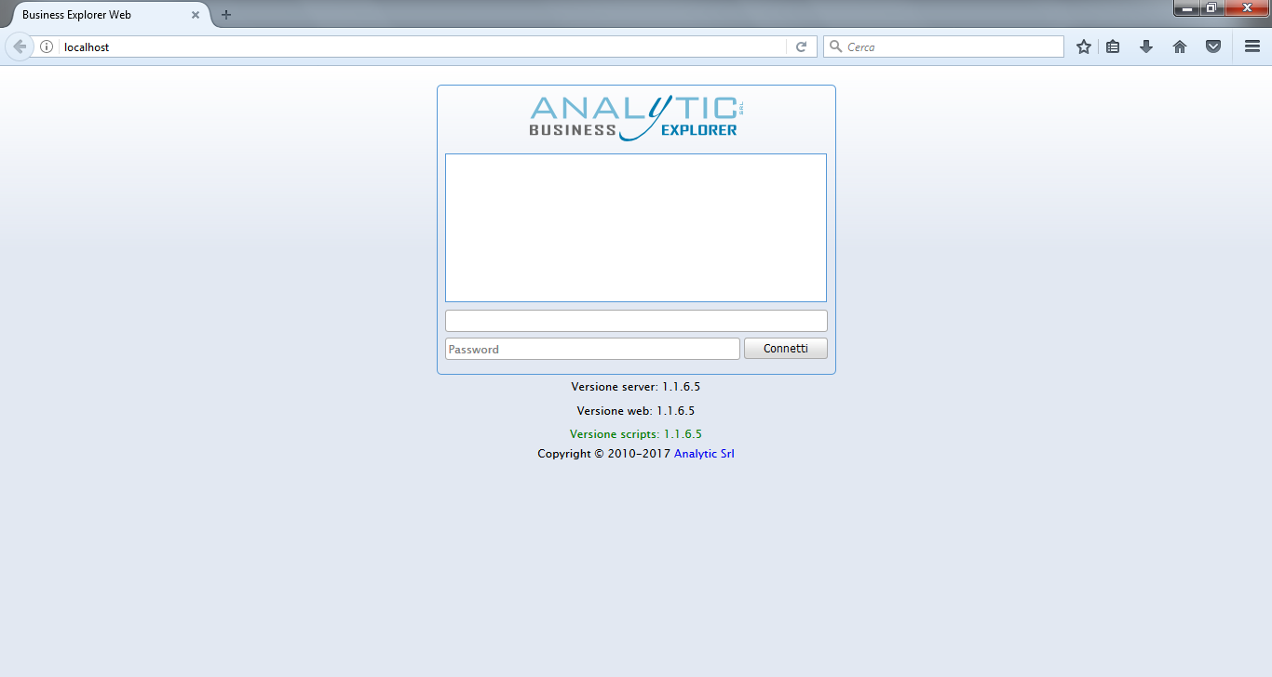
*Binding means that assigned when adding the site.

INSTALLING ANALYTIC BUSINESS EXPLORER SCHEDULER
Run as administrator be_scheduler_setup_xxx.exe by right-clicking on the file and selecting “Run as administrator”.
Follow the installation wizard by selecting “Next”.
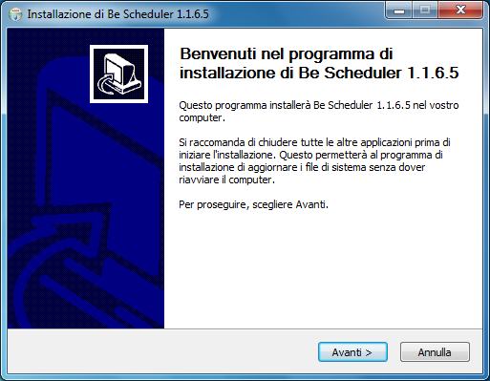
Specify the destination folder and select “Install”.
From the Windows toolbar select Start, search for Configure Business Explorer Scheduler and run it.
In the “Database Connection” tab fill in the “Server” field with the name of the server in question (“localhost” if there is only one instance) and the “Database” field with the name of the database containing the Business Explorer Server applications. Then fill in the “User” and “Password” fields if necessary.
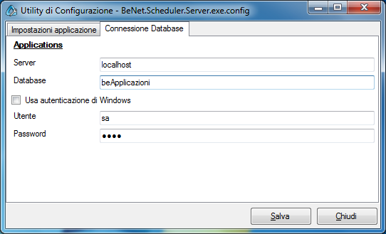
Finally click on the “Save” button.
Analytic Business Explorer Scheduler is installed and ready for use.

